1. The topology in the Smith Computer lab’s topology is a star, as the computers are all connected to a centralized point.

2. see drawing, all of the pcs in the picture that are wired are static ip’s. All of the wireless pc’s are dynamic.

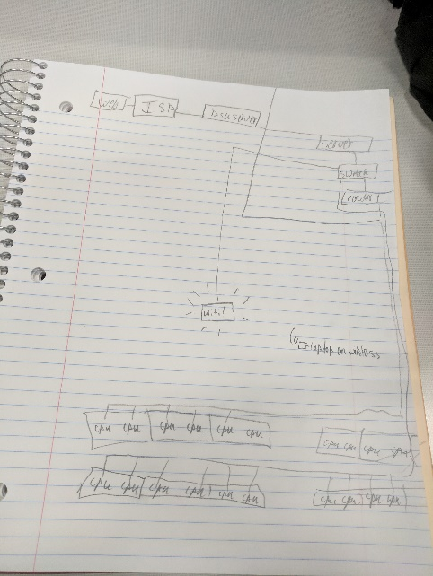

Cat 5e cables, switch, hard drives, router, server, computers, wireless router

3. ipv4:144.38.175.110

Gateway: 144.38.172.1

DNS: 144.38.43.11

Subnet mask: 255.255.252.0

4. A node(router), yes

5. 144.38.175.110, we have a public IP address

6. A name query is submitted – passed to a resolver for resolution – if query can be resolved, (server can match the response), the query is answered and the process is complete

7. 172.217.16.206

206.190.36.45

34.195.117.127

8. It wouldn’t load… Again, wouldn’t load… The query is being denied.

9. Yahoo!, turner broadcasting systems, PSINet

Whois gives us more info about the company, nslookup only gives the current ip address

10. the router’s site, the DNS, and ISP. It would show you where your internet connection is not working/disconnected.